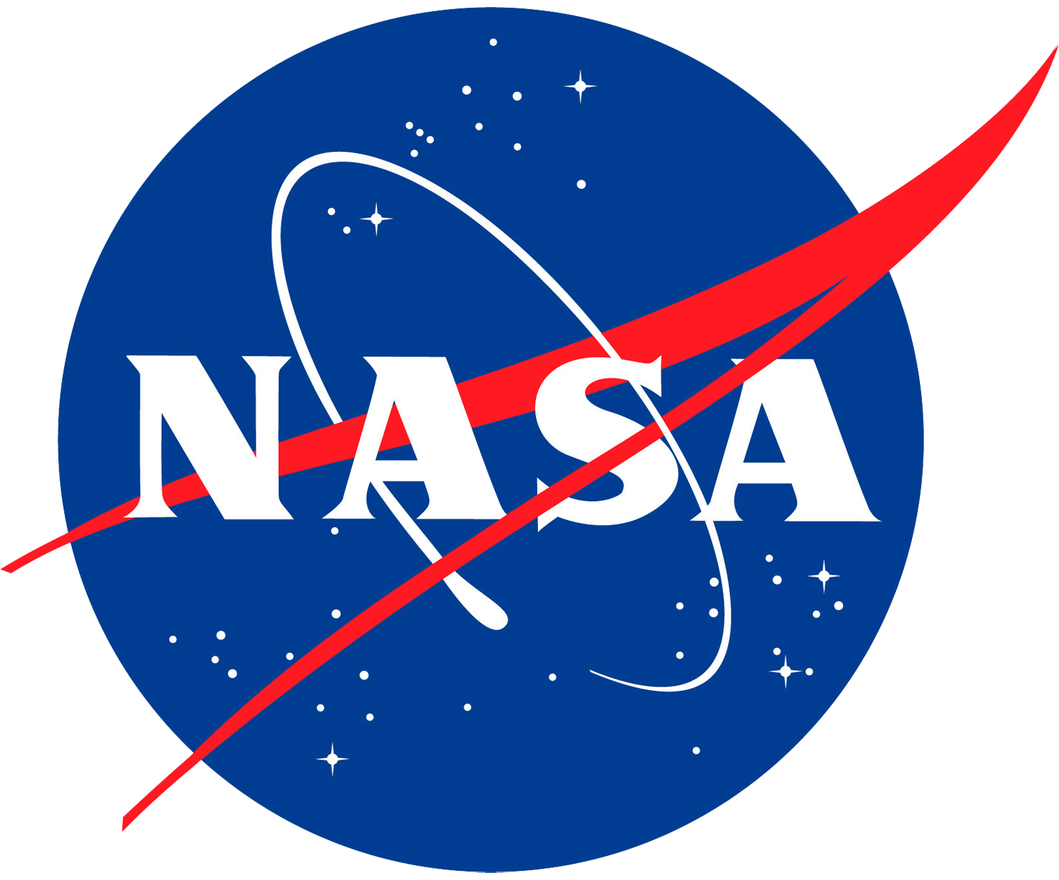

Sea Level Rise Online Learning Module
Educator’s Guide

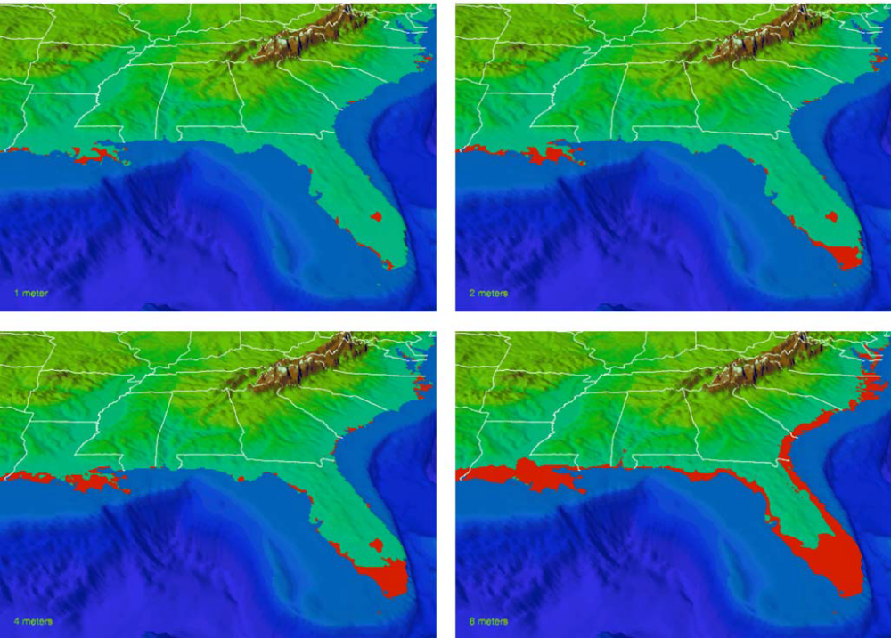

Grades: 6-12
Subject Areas: Earth and Human Activities

This Publication is in the public domain and is not protected by copyright
Permission is not required for duplication

Table of Contents

Introduction ……………………………………………….……… 3

Education Standards ..…………………………………............. 3
Next Generation Science Standards

Pre-Video Viewing Activities ..…………………………….…... 4

Activities While Viewing the Video ………..…………………. 4

Post-Video Viewing Activities ..……………………………….. 5

Additional Resources …..………………………………………. 5

Page 2 of 5
Introduction

This online learning module allows students to learn about sea level rise, its causes, and impacts; and challenges students to think about what they can do in response. This module features an integrated educational package of grade-appropriate instruction and activities centered on a 23 minute video presentation. Please note, the video has numerous scheduled paused within it so educators may facilitate discussion of presented topics. This will extend the viewing time of the video

Grade Level: 6 - 12

Focus Question: What is causing sea level rise and what can be done about it?

5-E Learning Objectives:

The Learner will
Engage: recall prior knowledge related to sea level and sea level rise
Explore: explore resources and materials that indicate sea level is rising
Explain: explain the causes of sea level rise
Elaborate: apply new knowledge to understand how their actions impact sea level rise and climate change.
Evaluate: calculate their carbon footprint and determine what, if any, changes can be made.

Education Standards

Next Generation Science Standards
MS-ESS3-3: Apply scientific principles to design a method for monitoring and minimizing a human impact on the environment.
MS-ESS3-5: Ask questions to clarify evidence of the factors that have caused the rise in global temperatures over the past century.
HS-ESS3-5: Analyze geoscience data and the results from global climate models to make an evidence-based forecast of the current rate of global or regional climate change and associated future impacts to Earth systems.
HS-ESS3-6: Use a computational representation to illustrate the relationships among Earth systems and how those relationships are being modified due to human activity.

Page 3 of 5

Pre-Video Viewing Activities

Teacher background information:
- IPCC Fact Sheet: Is Sea Level Rising - http://oceanservice.noaa.gov/education/pd/climate/factsheets/issea.pdf

- IPCC Fact Sheet: How do Human Activities Contribute to Climate Change and How do They Compare with Natural Influences?
http://oceanservice.noaa.gov/education/pd/climate/factsheets/howhuman.pdf

Grades 6-8:
NOAA Ocean Explorer Multimedia Discovery Mission: Tides -
http://oceanexplorer.noaa.gov/edu/learning/player/lesson1O.html

Grades 9-12:
Lesson Plan - Ups and Downs - What Causes Tides and Tidal Currents:
http://oceanservice.noaa.gov/education/lessons/ups_downs.html

Activities While Viewing the Video

During the video there are several pauses for discussion, and one pause for students to complete a sea level rise graphing exercise. It is strongly advised that educators view the video in its entirety prior to showing it to students/audiences.

Print the Sea Level Rise Graph PDF for use during min 07:14 of the video – one per student (Insert Full Document Link/URL Here)

Outline of Video
- Tides and Water Levels
- Sea Level Rise
  - Sea Level
  - Sea Level Rise Evidence
  - Sea Level Rise Causes
  - Sea Level Rise Impacts

Page 4 of 5

Post-Video Viewing Activities

Teacher Background Information:
http://oceanservi ce.noaa.gov/education/pd/cli mate/factsheets/whatg reenhouse.pdf

Data in the Classroom:
http://dataintheclassroom.noaa.gov/SitePages/sea-level/index

Data in the Classroom Curriculum Guide:
http://dataintheclassroom.noaa.gov/SitePages/sea-level/teachers#.VhKG-flVhBc
(required for Data in the Classroom)

Calculating Your Carbon Footprint:
http://www.esrl.noaa.gov/gmd/outreach/lesson plans/Calculating Your Carbon Footprint.pdf

Additional Resources:
- NOAA National Ocean Service Education - Ocean and Climate Literacy: http://oceanservice.noaa.gov/education/literacy.html
- NOAA National Ocean Service Education - Climate Resources: http://oceanservice.noaa.gov/education/pd/climate/welcome.html
- NOAA National Ocean Service Education – Tides and Water Levels: http://oceanservice.noaa.gov/education/tutorial_tides/welcome.html

Ten Signs of a Warming World:
http://cpo.noaa.gov/warmingworld/global_sea_level.html

Sea Level Rise Viewer: http://coast.noaa.gov/digitalcoast/tools/sl

Page 5 of 5

